Capstone Project – 1

1. Object Creation:

Create custom objects named

1. Course
2. Subjects
3. Course Leads
4. Technology

Screenshot:- 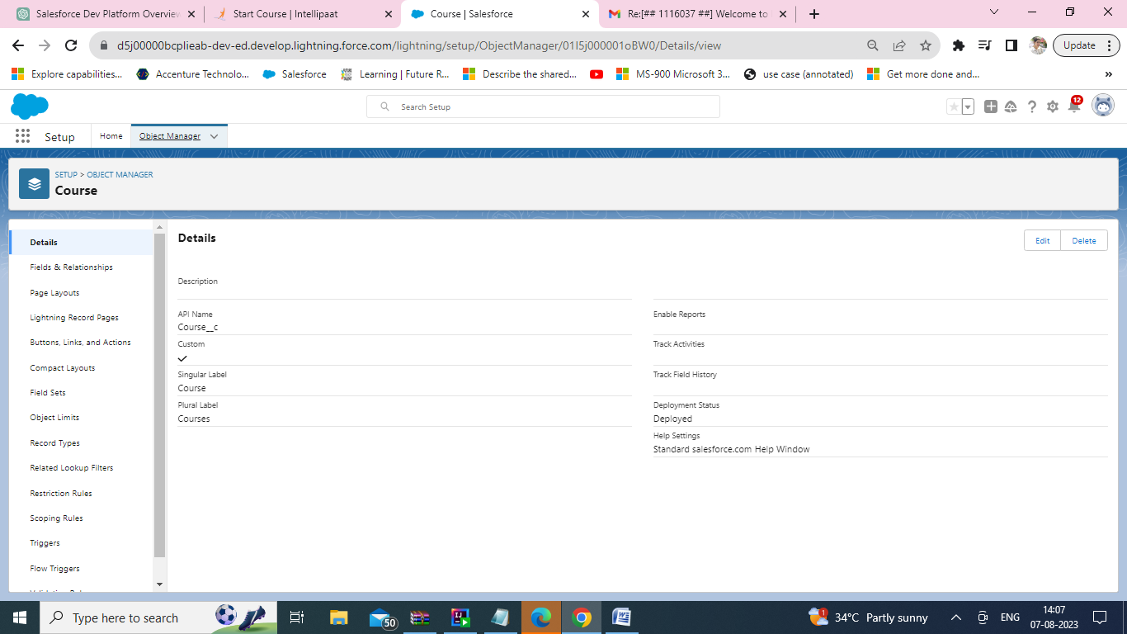

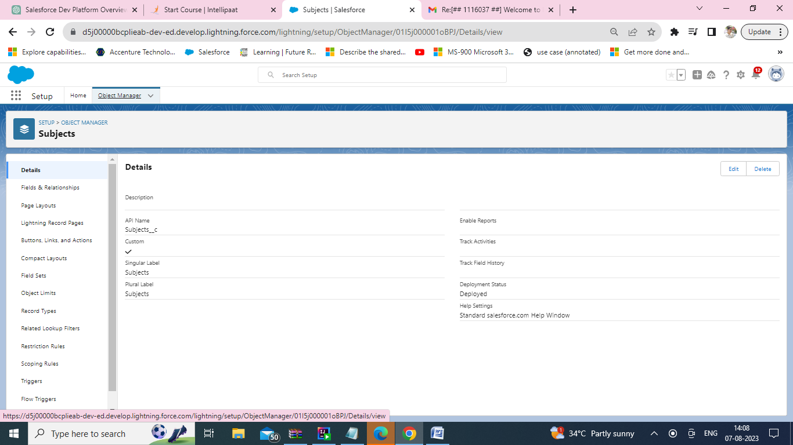

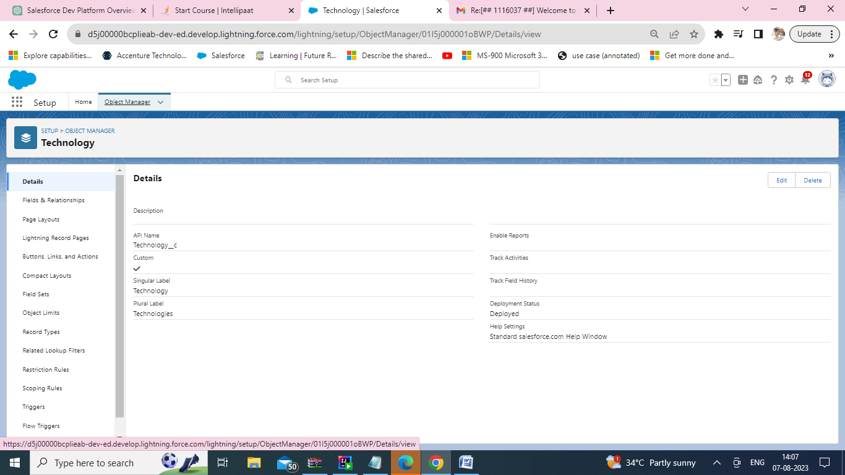

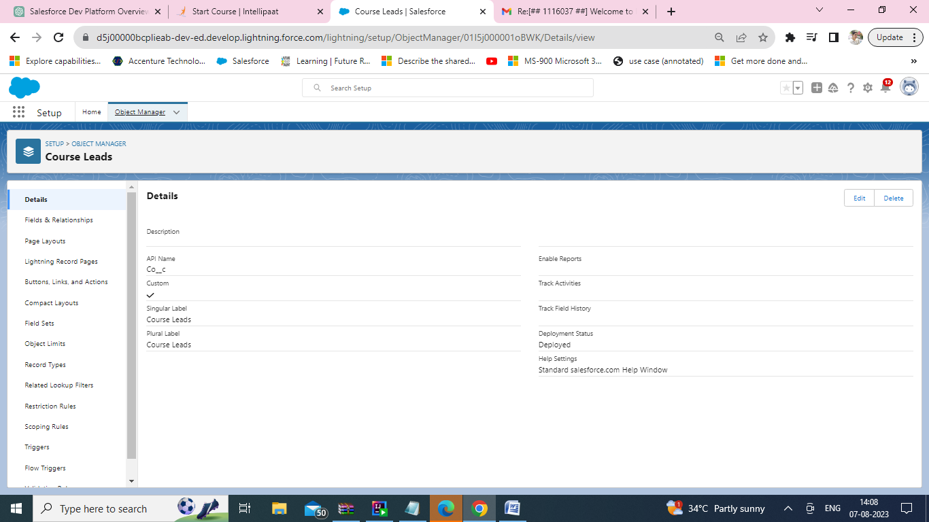

1. Field Creation:

Create fields for the above objects

1. Course

a) Course Name

b) No. of Modules

c) Course Duration

d) Rating

e) Active

f) Instructor Name

g) Type of Course

h) Priority

i) Start Date

j) End Date

Screenshot:- 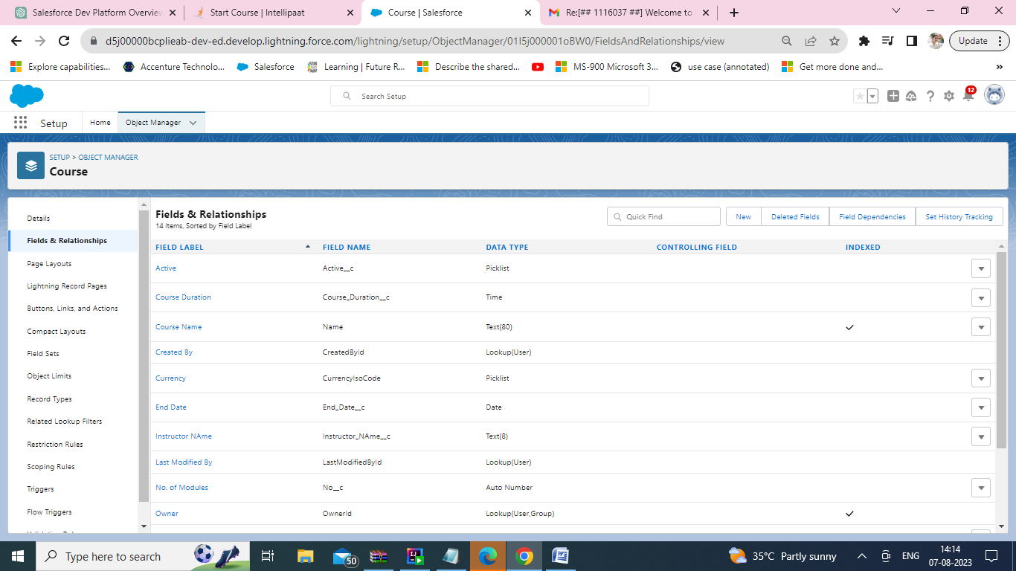

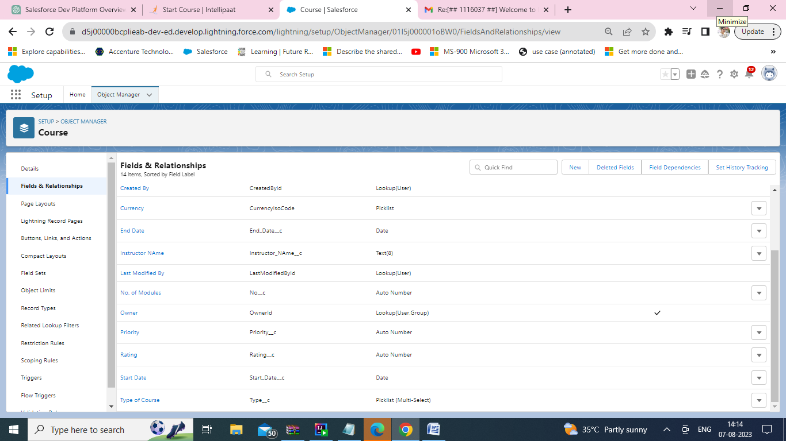

1. Subject
2. Subject Name
3. No. of Modules
4. Instructor Name
5. Rating
6. Priority
7. Category
8. Level

Screenshot:- 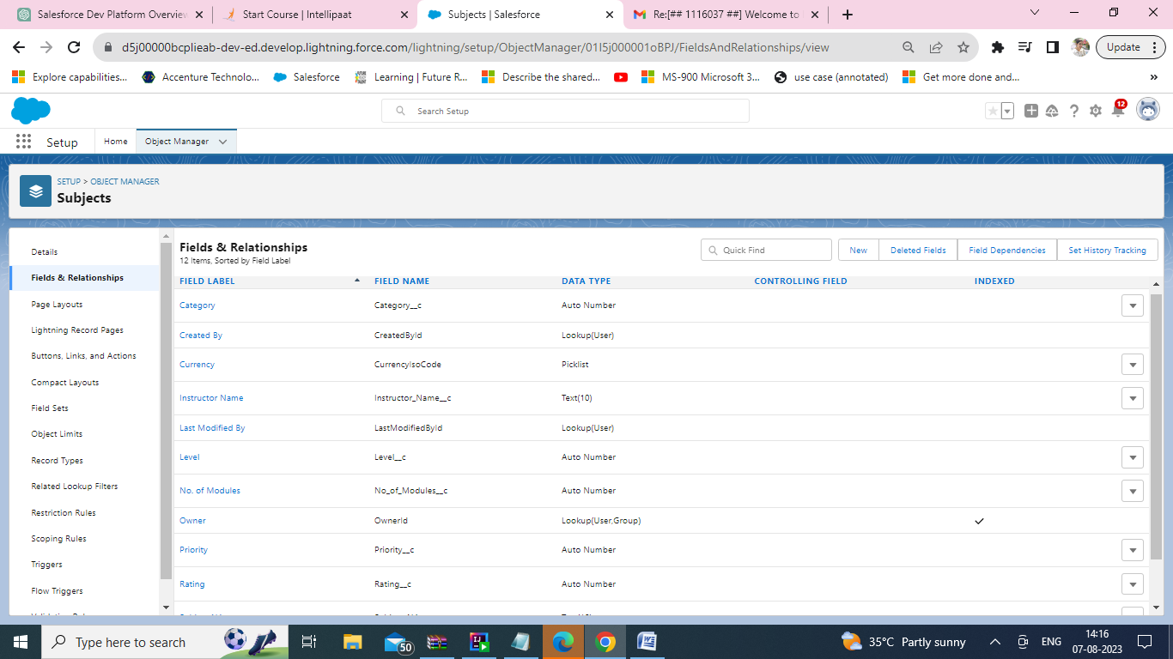

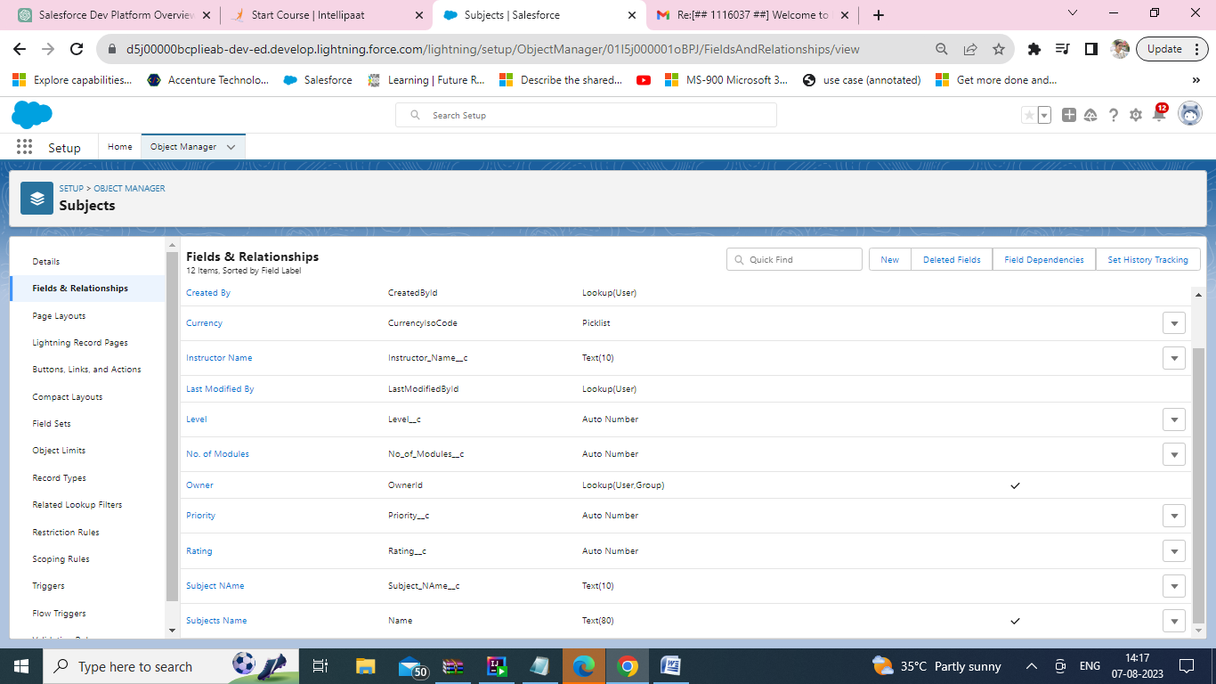

3) Course Leads

a) First Name

b) Last Name

c) Phone

d) Email

e) Source

f) Category

g) Rating

h) Currency

i) Course Lead Amount

Screenshot:- 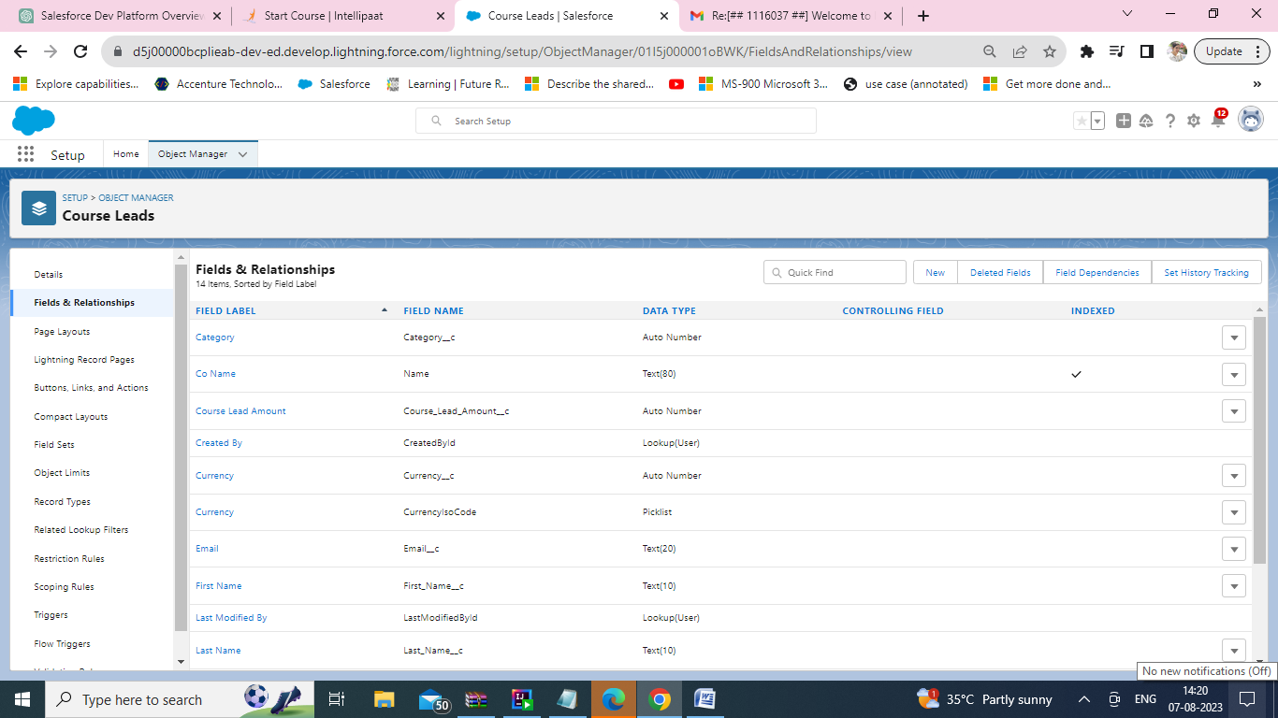

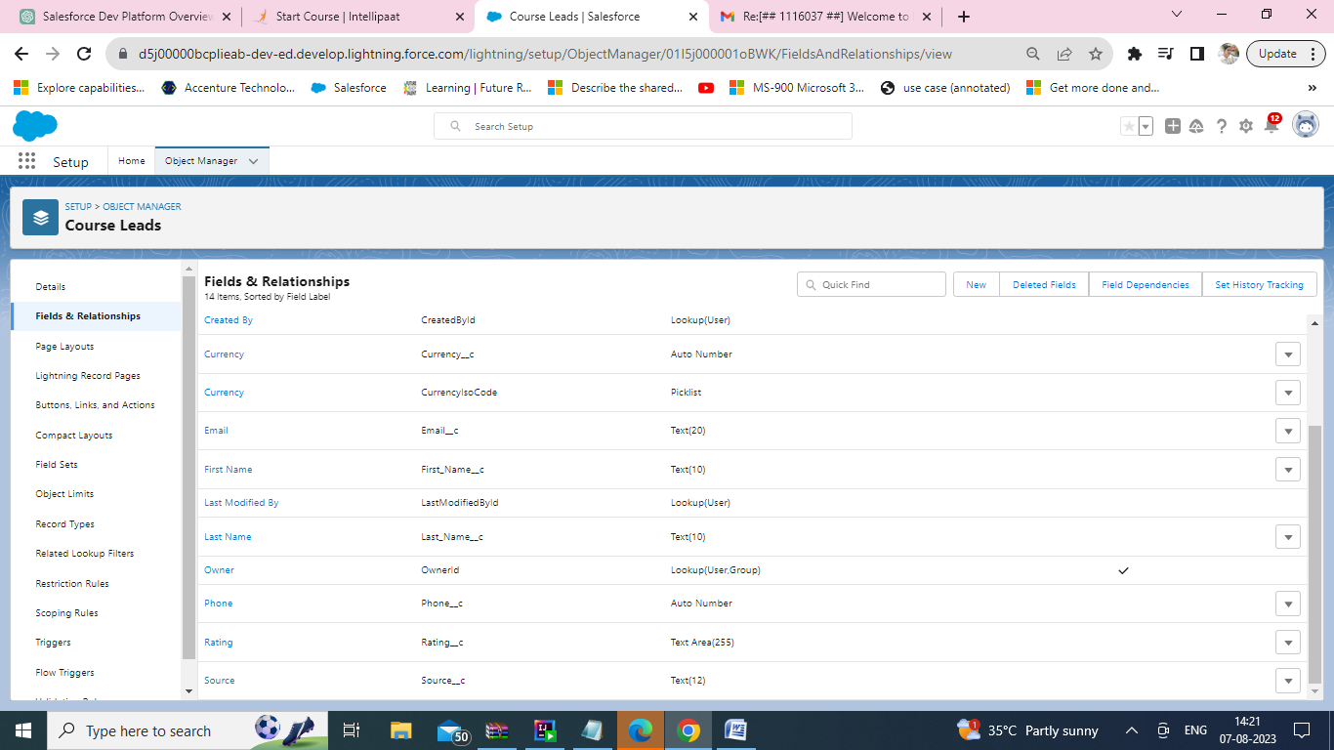

4) Technology

i) Name

ii) Type

iii)Category

iv)Rating

v)Active

vi)Instructor Name

a)Mobile b) Email c) Qualification d) Availability

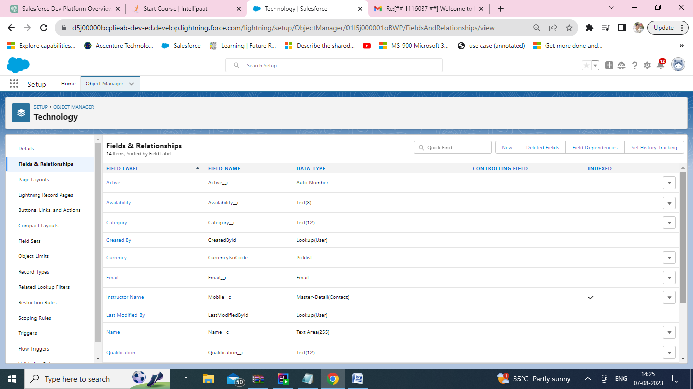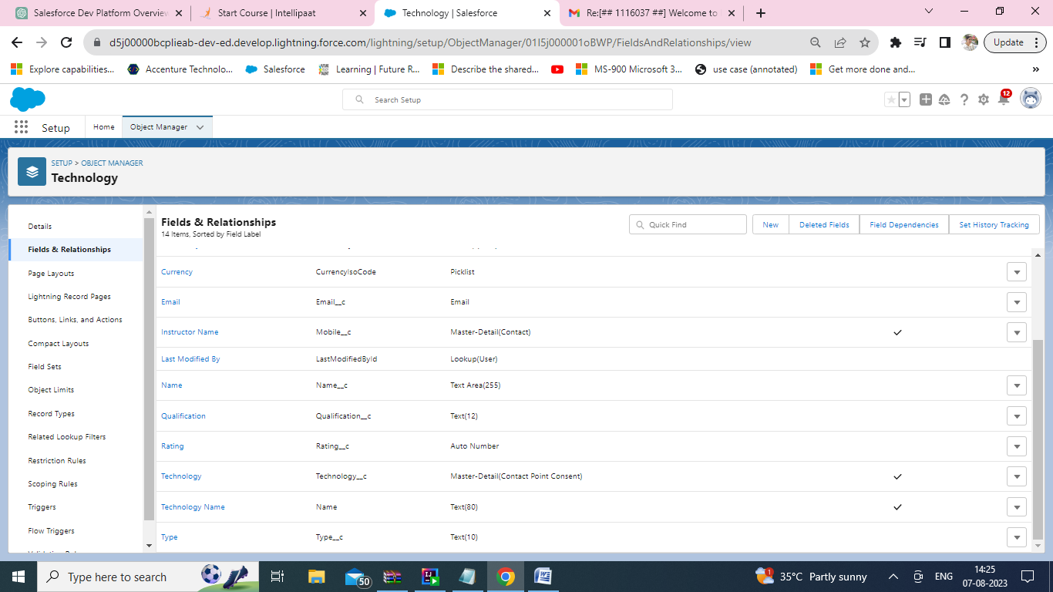

1. Add Validation Rules for verifying data

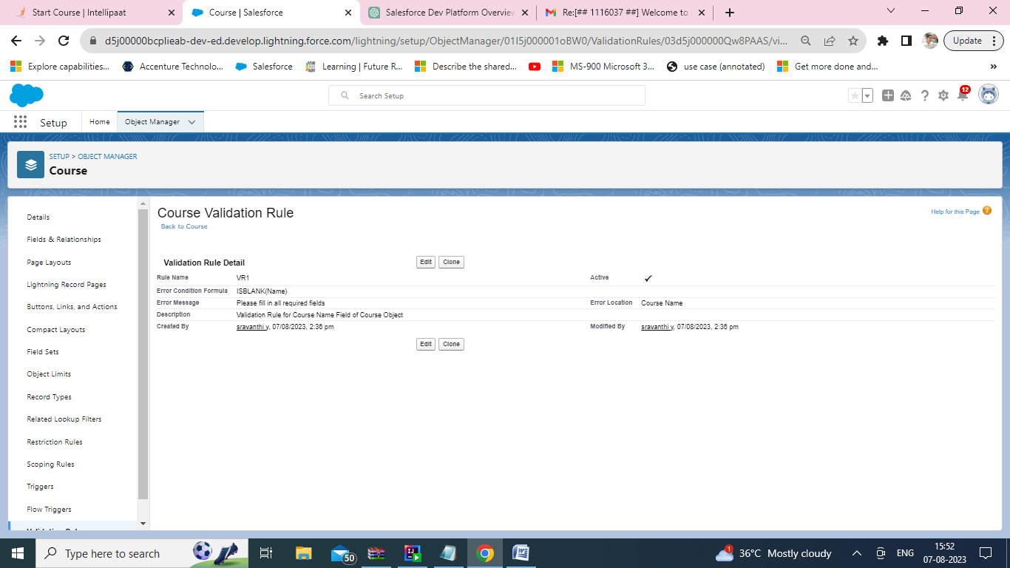

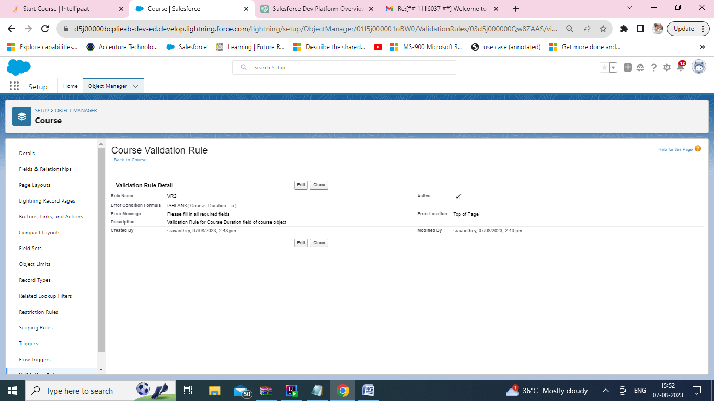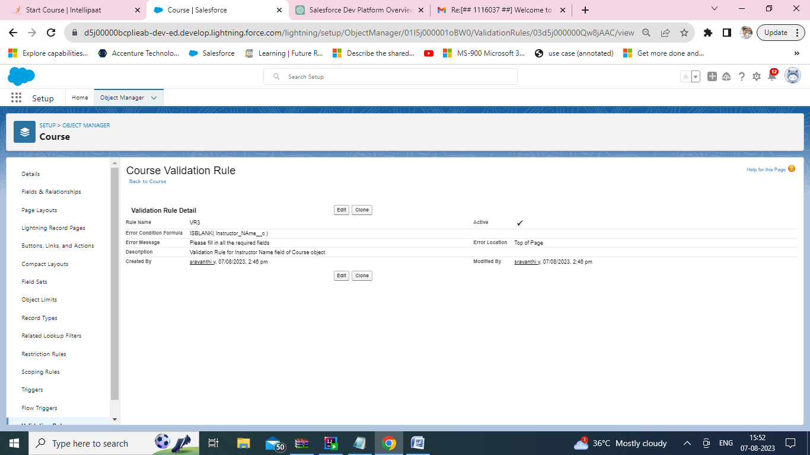

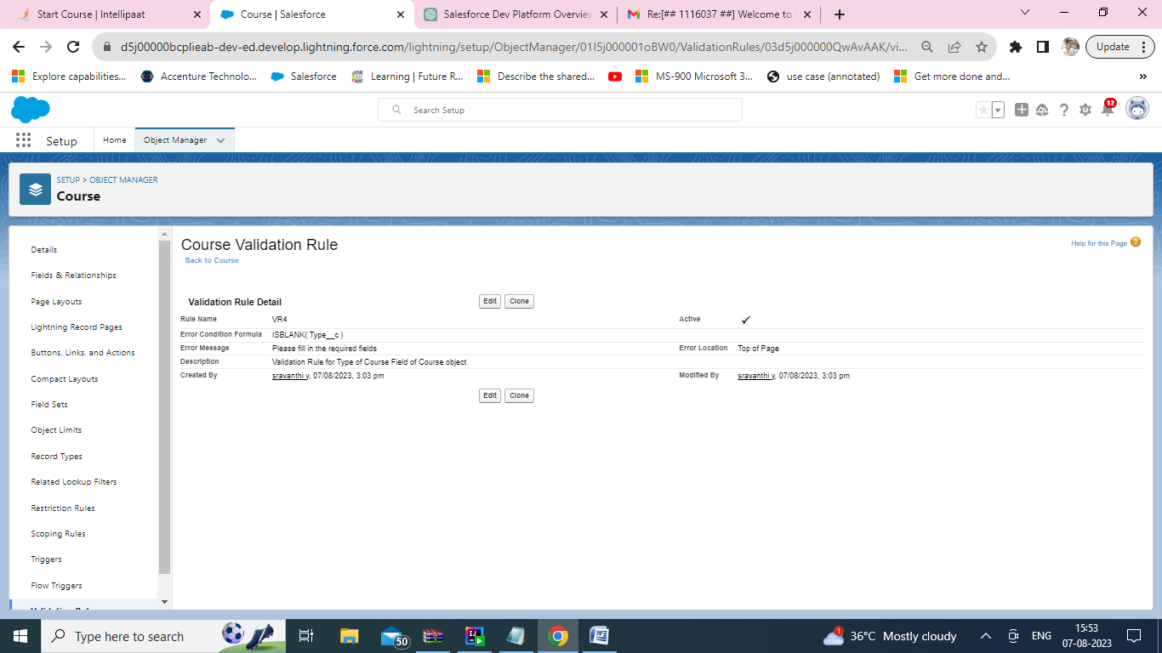

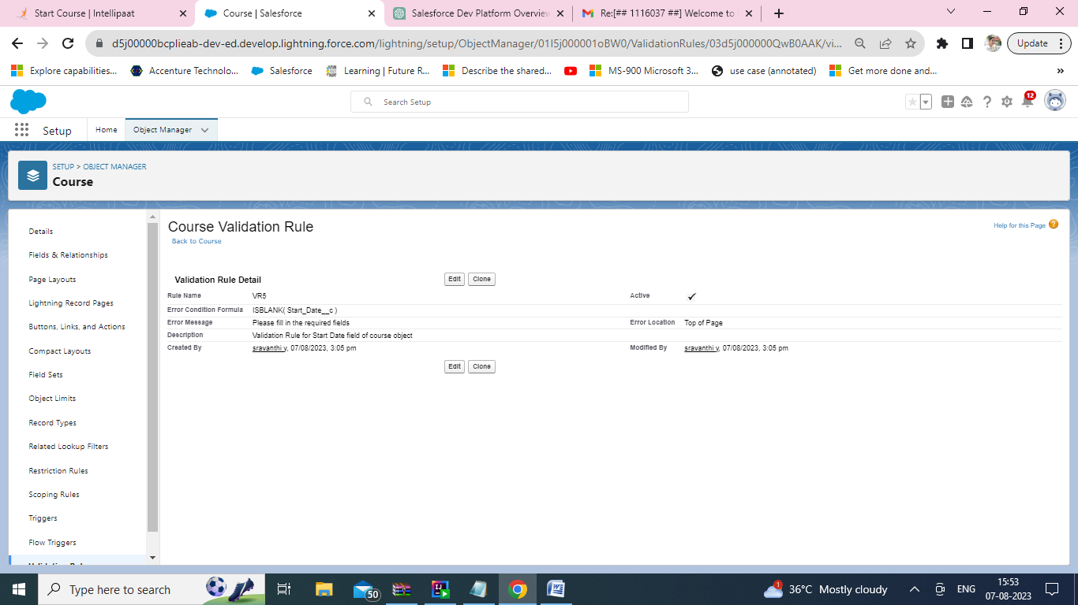

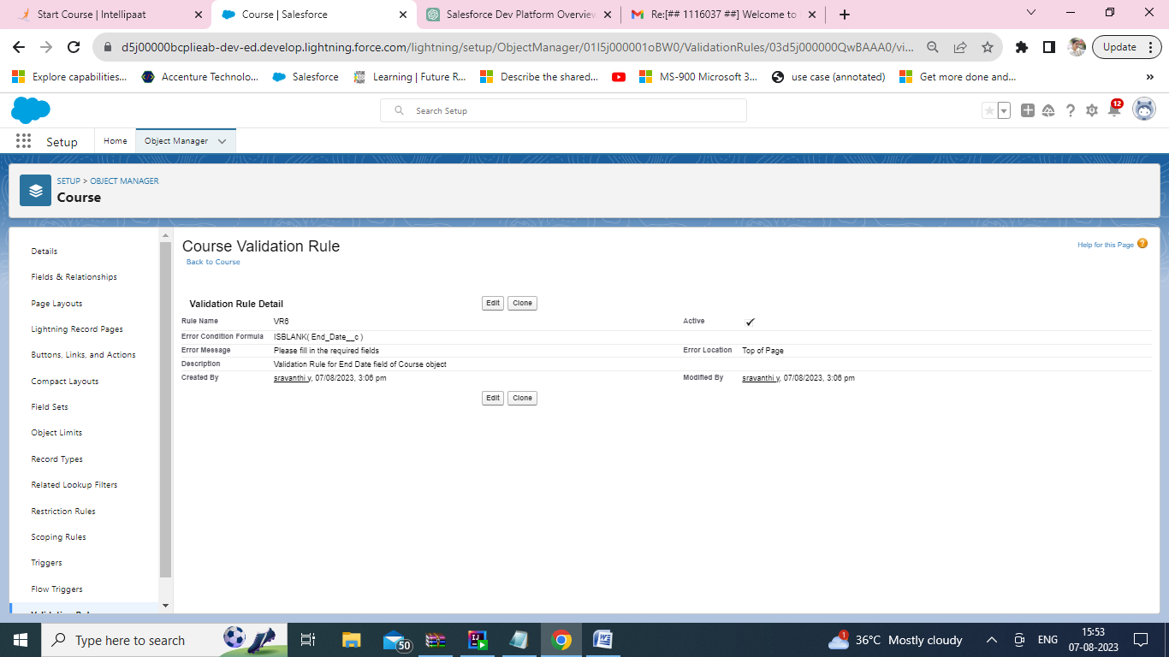

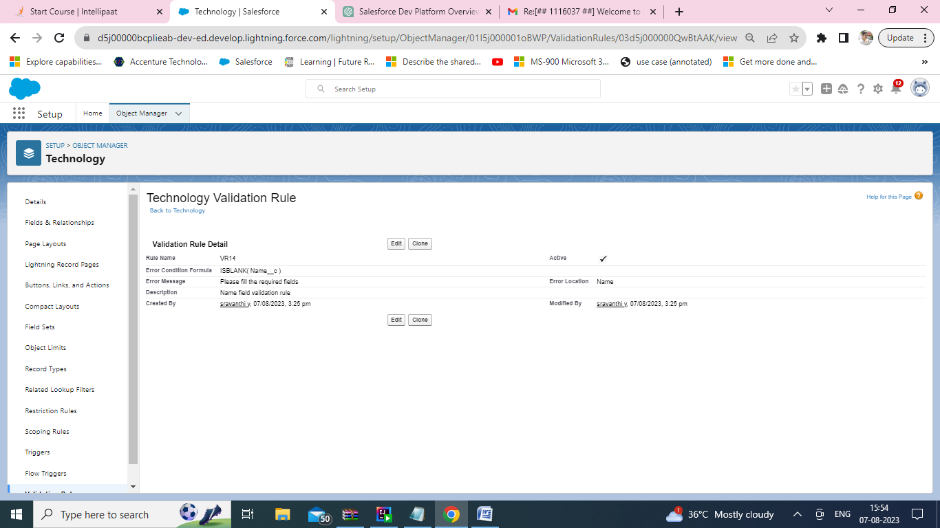

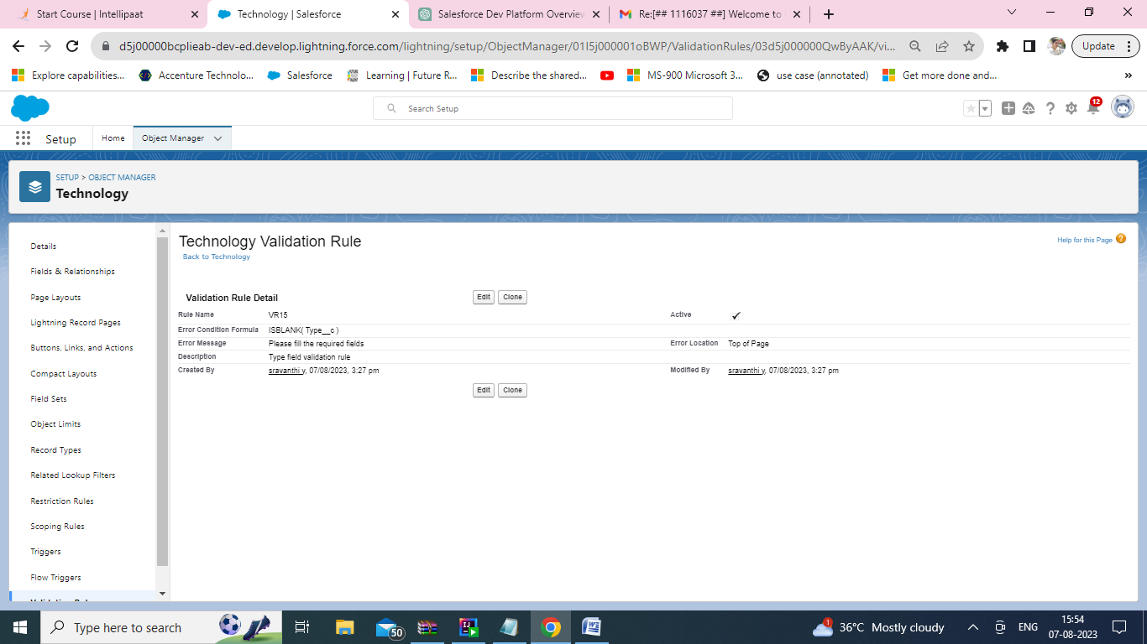

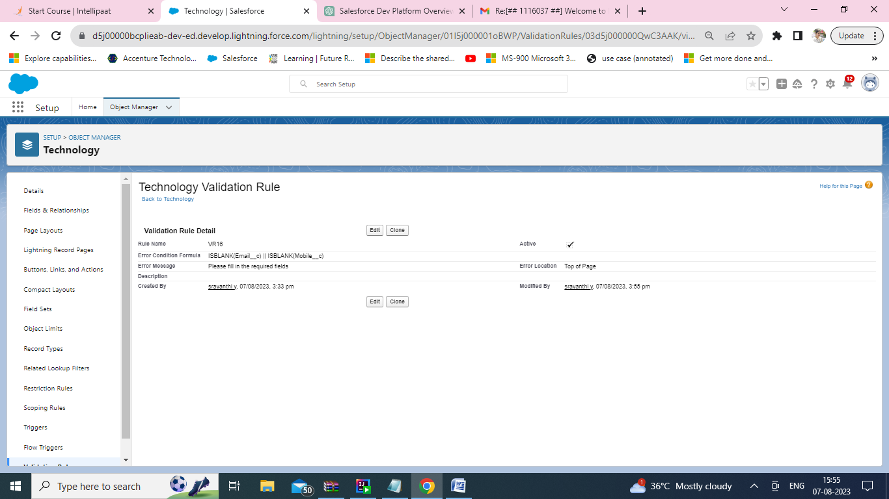

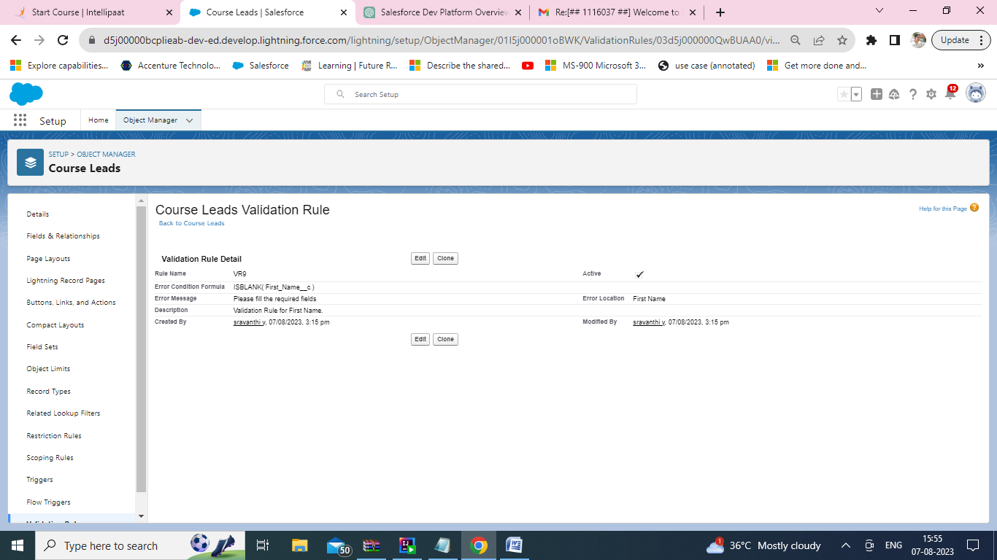

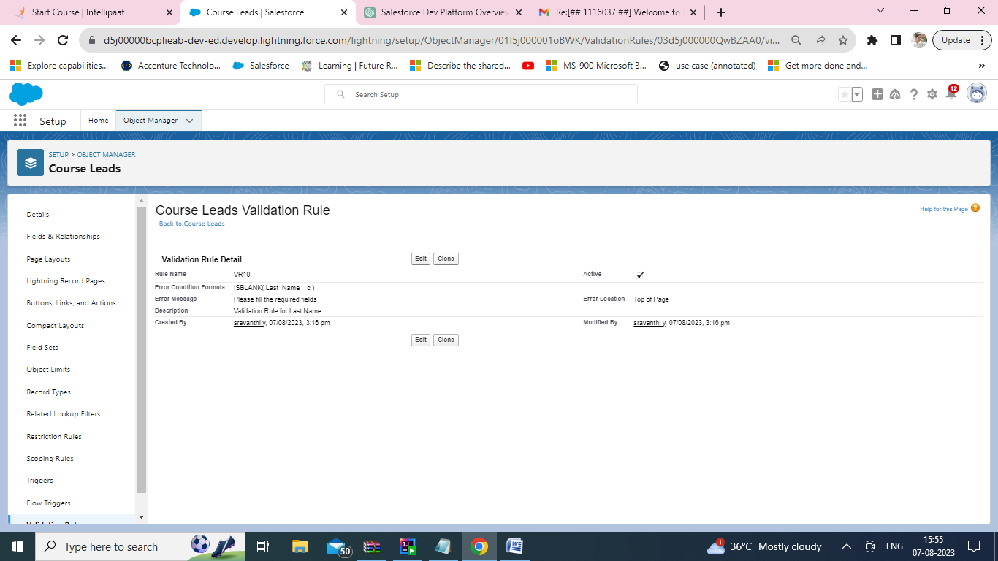

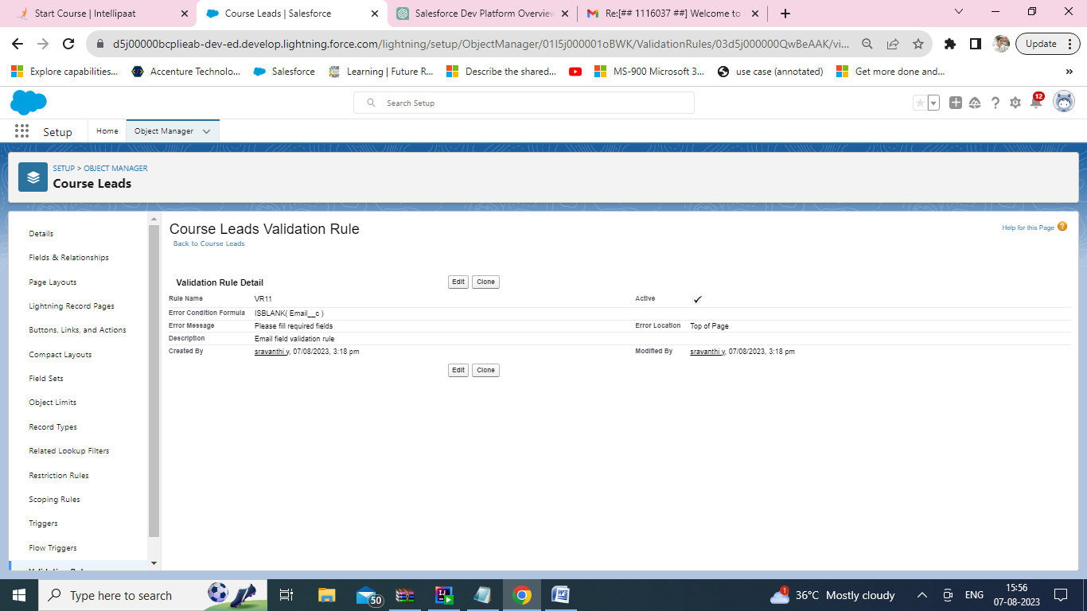

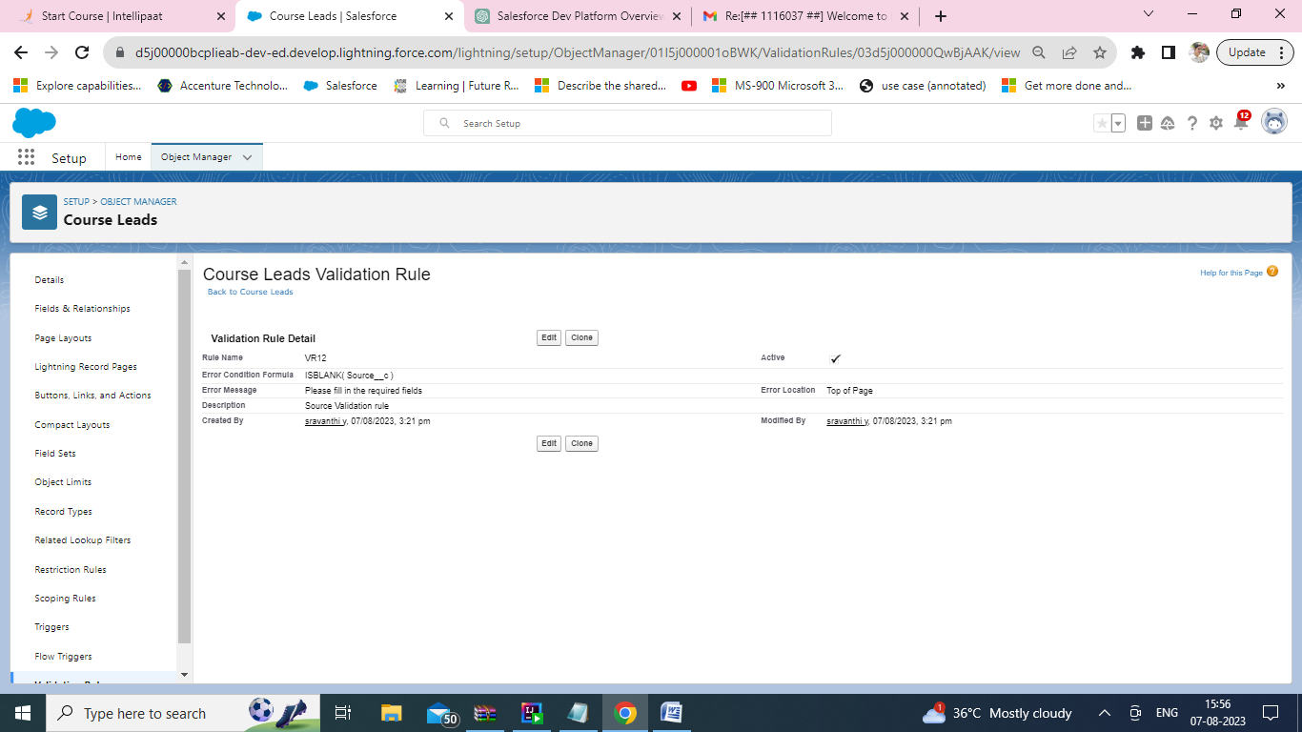

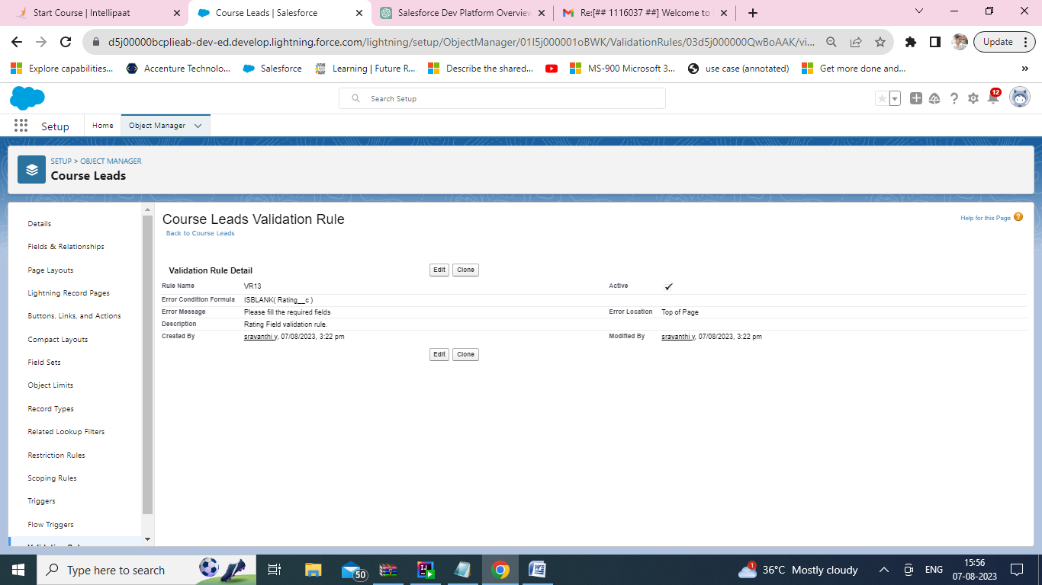

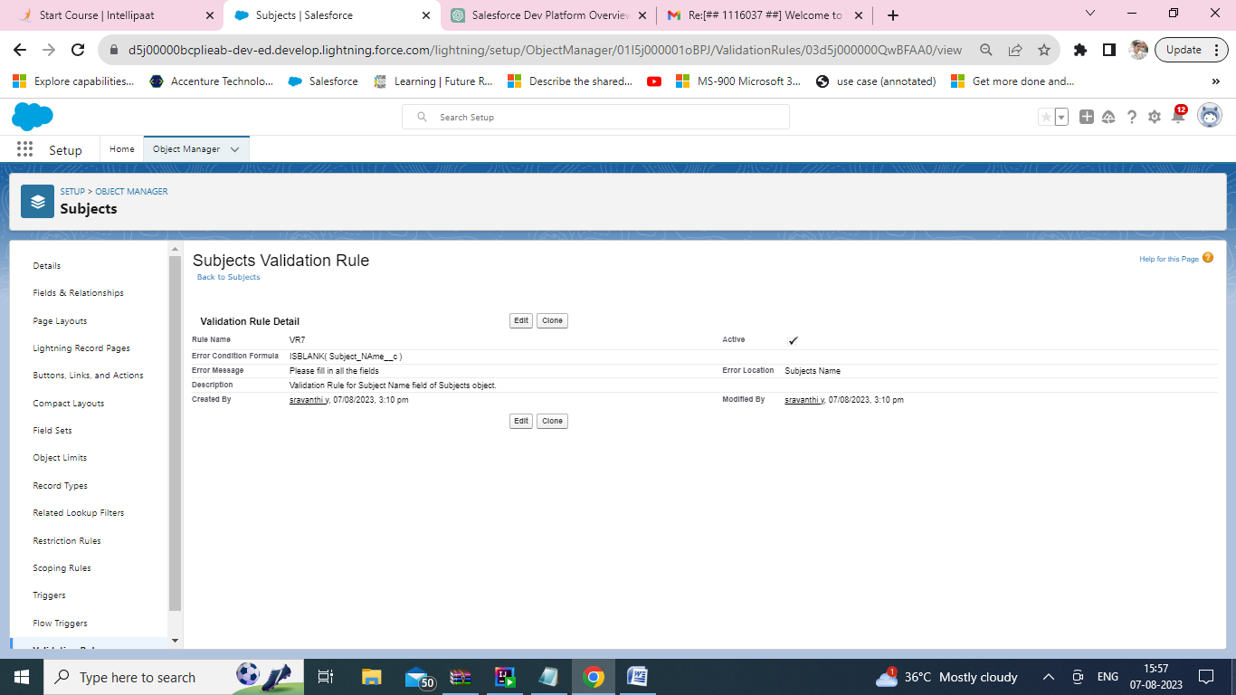

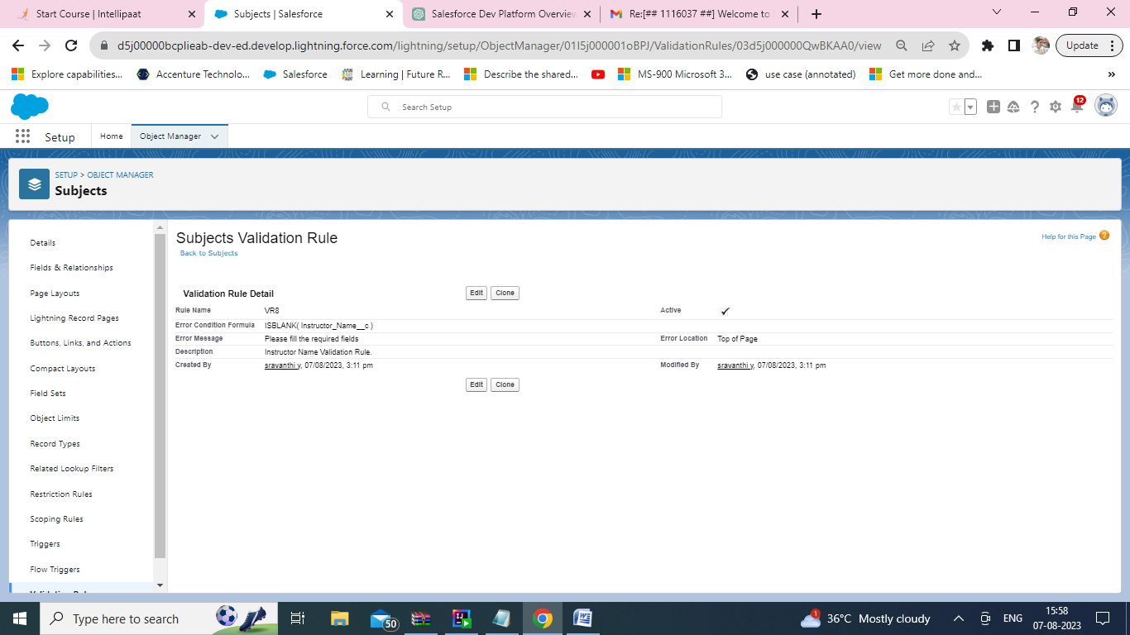

1. Set workflow rules for the custom objects created. The workflow rules should be created in such a way that it should update the data after the following criteria is met:
2. If the priority is high update the course name to 'High Priority' + Course Name

Screenshot:- 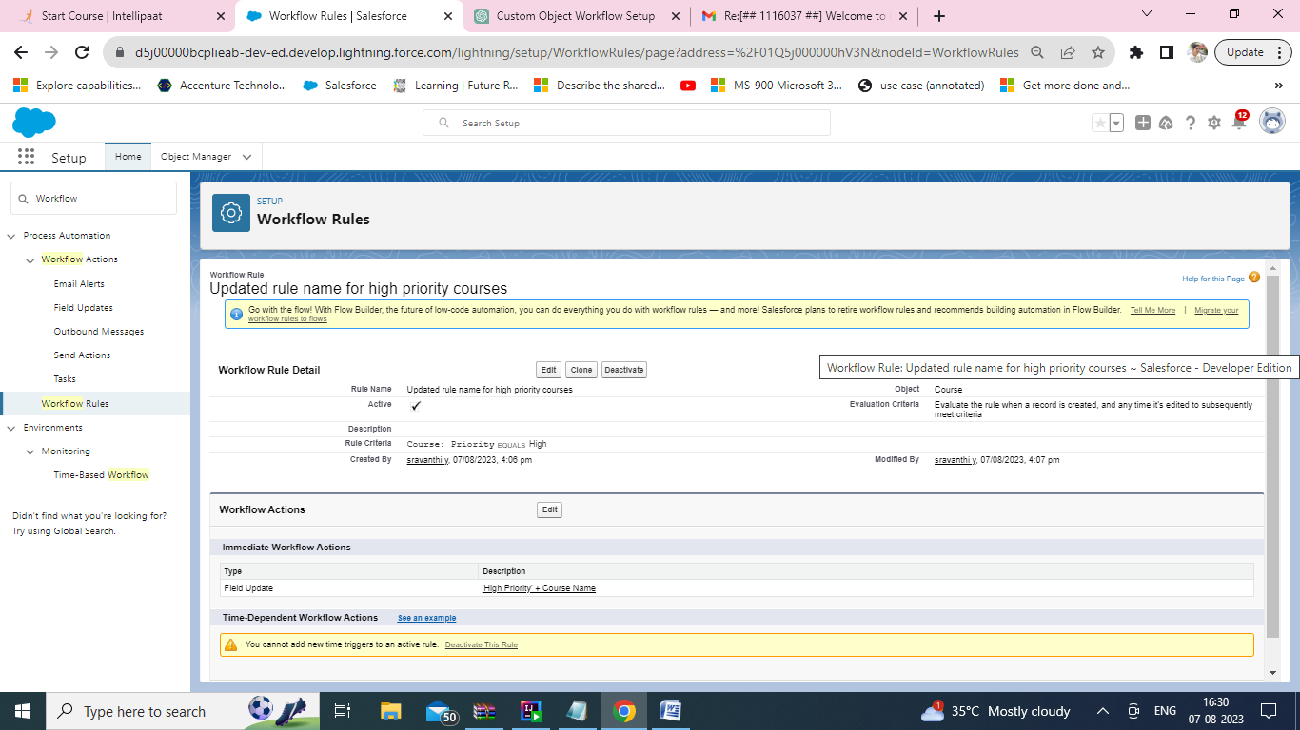

1. If the Lead Amount is greater than $1000,then update the name field to ‘Top Priority Customer’ + Name

Screenshot:- 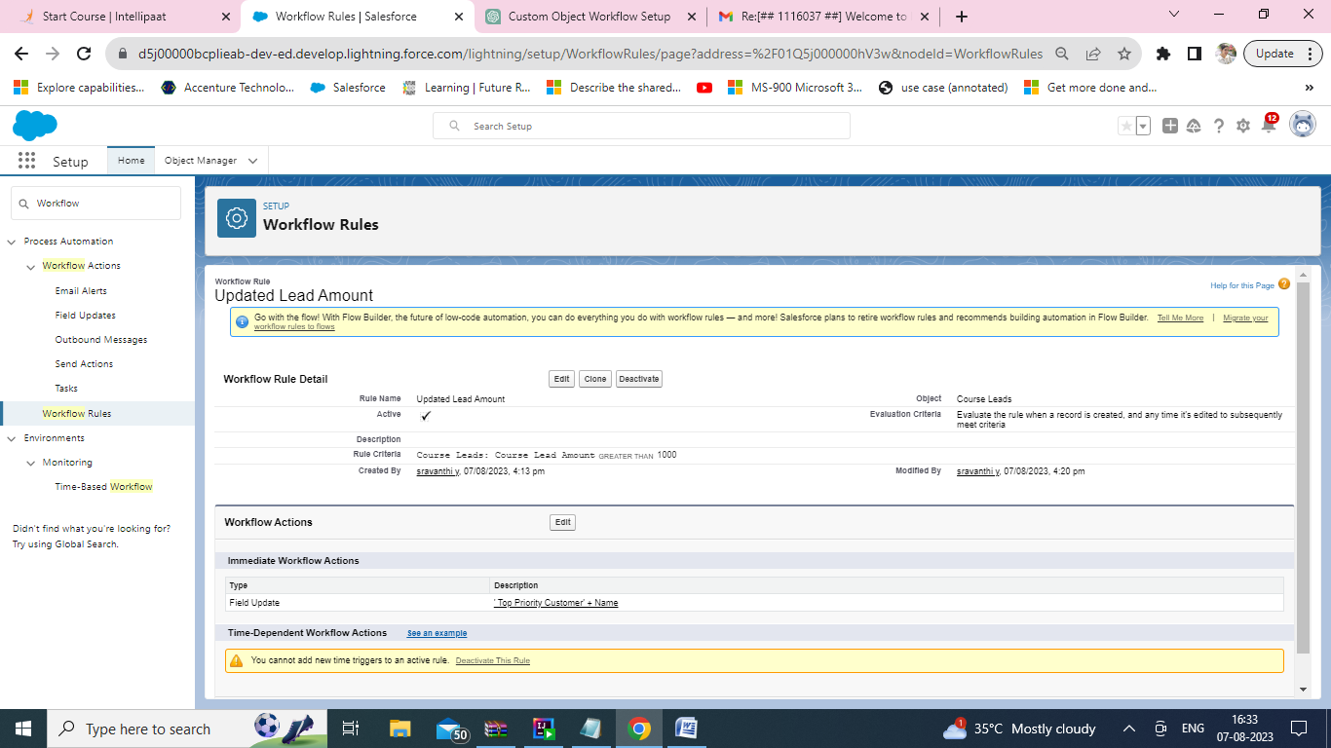

1. Create a flow using the below scenario for creating a case.

First the user should enter the following fields in the case: Name,Phone,Email,Course Enrolled,Subject,Instructor Name,Query Description. After the case is created,assign the case to the Course Instructor. If the instructor is unavailable, assign it to specific executive of the company. Further when the query is resolved, update the case as 'Resolved'

